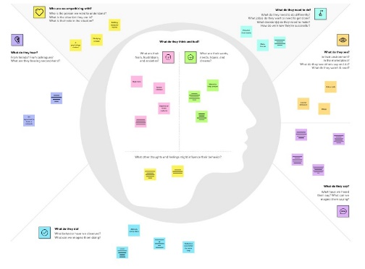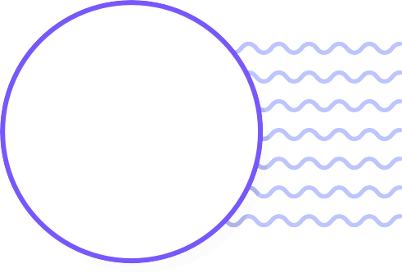

**Template**

Empathy map canvas

Use this framework to empathize with a customer, user, or any person who is affected by a team’s work.

Document and discuss your observations and note your assumptions to gain more empathy for the people you serve.

Originally created by Dave Gray at

**Share template feedback**

**Need some inspiration?**

See a finished version of this template to kickstart your work.

**Open example**

✴

**Develop shared understanding and empathy**

Summarize the data you have gathered related to the people that are impacted by your work. It will help you generate ideas, prioritize features, or discuss decisions.

# WHO are we empathizing with?

Who is the person we want to understand? What is the situation they are in?

What is their role in the situation?

# GOAL

**What do they need to DO?**

What do they need to do differently? What job(s) do they want or need to get done? What decision(s) do they need to make?

How will we know they were successful?

Automation of hospital administrative process

Understanding is much deeper than knowledge

# What do they THINK and FEEL?

If you can positive

Allocation room based on patient health

**What do they HEAR?**

What are they hearing others say? What are they hearing from friends? What are they hearing from colleagues? What are they hearing second-hand?

# PAINS

What are their fears, frustrations, and anxieties?

# GAINS

What are their wants, needs, hopes, and dreams?

Organizing data

Smart hospital management

Clear cut view of number of cases , bed,stay available

# What do they SEE?

It can dynamically change the details using dash board

Hoe to find the patient LOS

What do they see in the marketplace? What do they see in their immediate environment? What do they see others saying and doing?

Easy to identify number of patient who are at high risk

What are they watching and reading?

Is an important indicator of the efficiency of hospital management

It is used to patient quality of care and functional evaluation

What other thoughts and feelings might influence their behavior?

More effective sharing the patient data

# What do they SAY?

What have we heard them say? What can we magine them saying?



Behaviors are out world wardly reflect how we are felling on they inside

Sequence thoughts create feelings

Explore and visualize the hospital data set efficiently

Mentors other developers

# What do they DO?

Proper resource allocation for patient

Easy to attend patient on time

What do they do today?

Ease of usuability

What behavior have we observed? What can we imagine them doing?